# Reading 1: Get ready to read P142

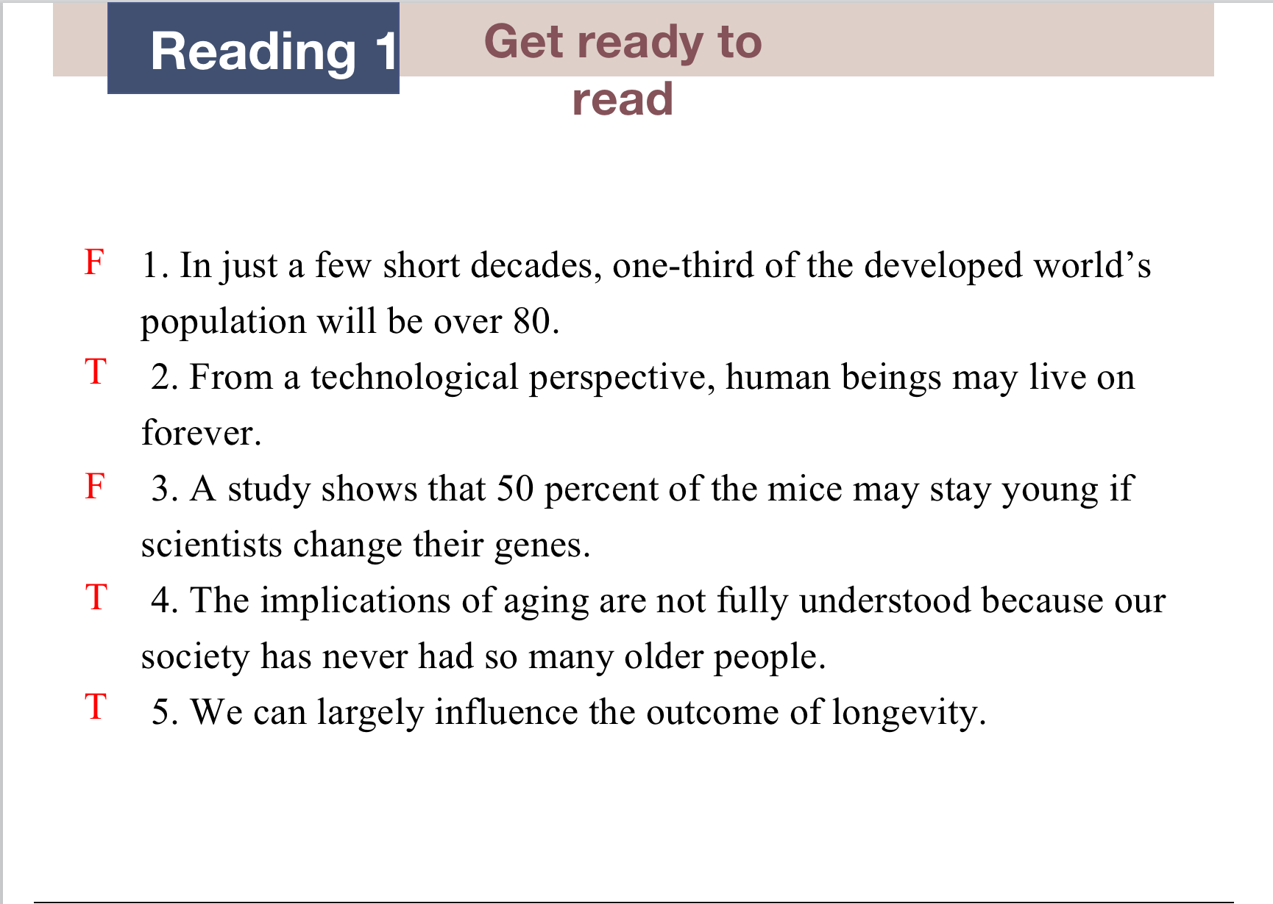

# Reading 1: Global Understanding P145

1. abolished 2) commonplace 3) running a marathon 4) average and maximum 5) repaired and replaced 6) optimized 7) anti-aging 8) trap 9) are crammed into 10) age badly

Detailed understanding: T, T, T, NG, F, NG, T, F,

# Reading 1: Read and practice P147

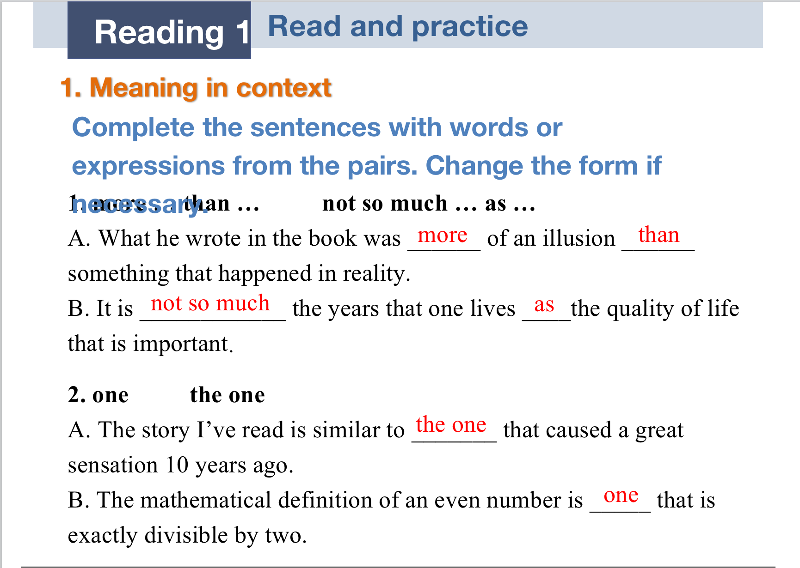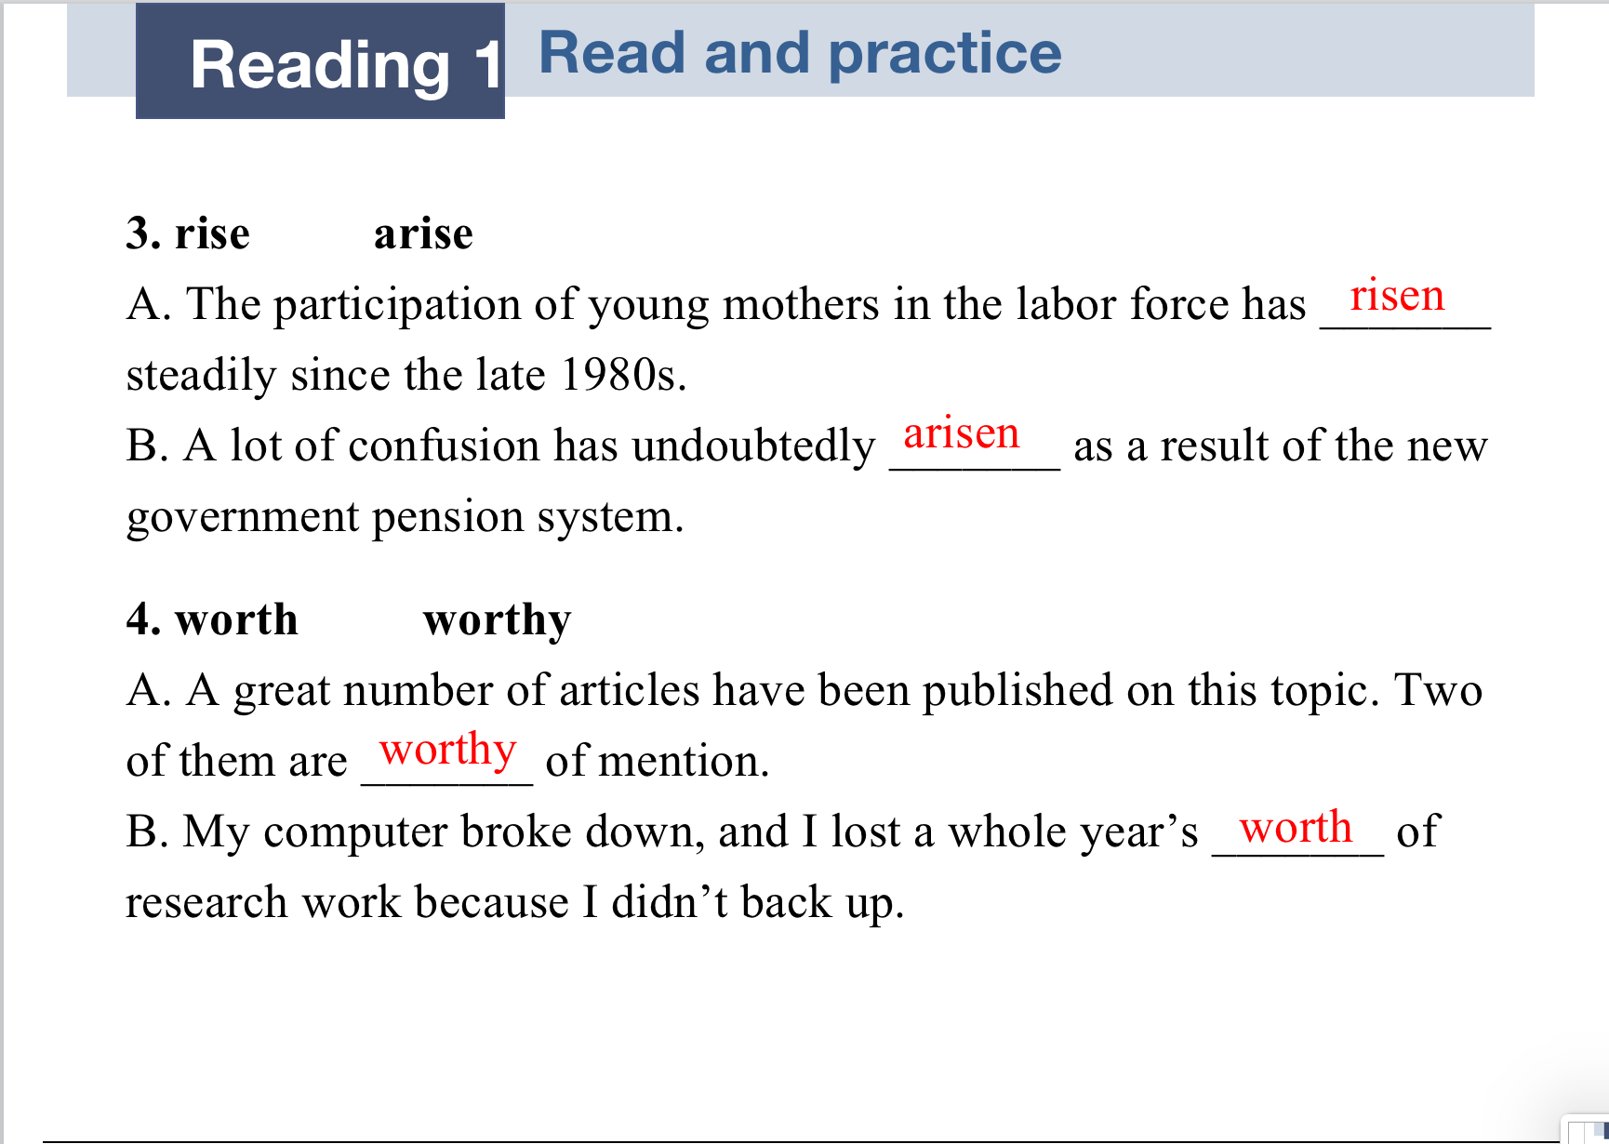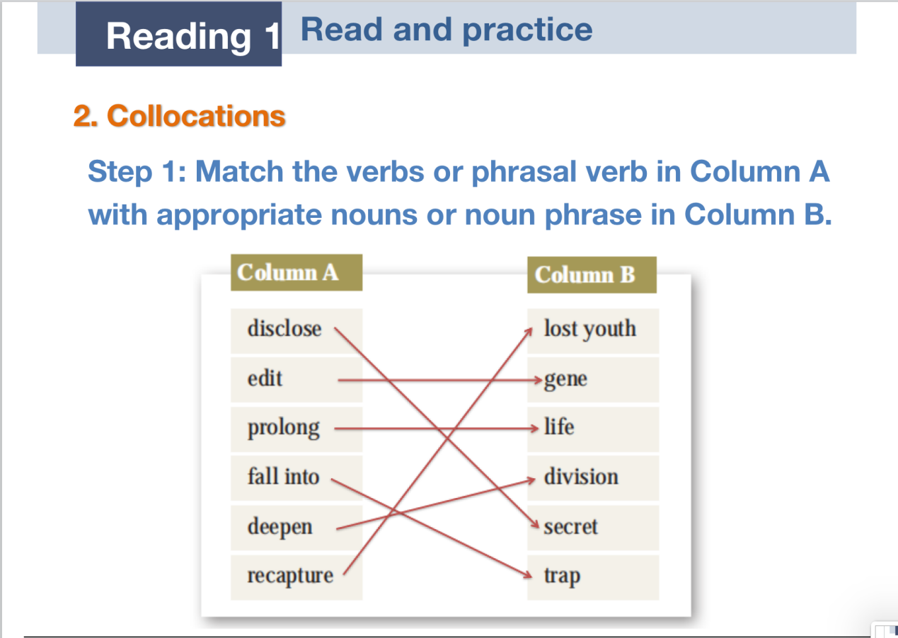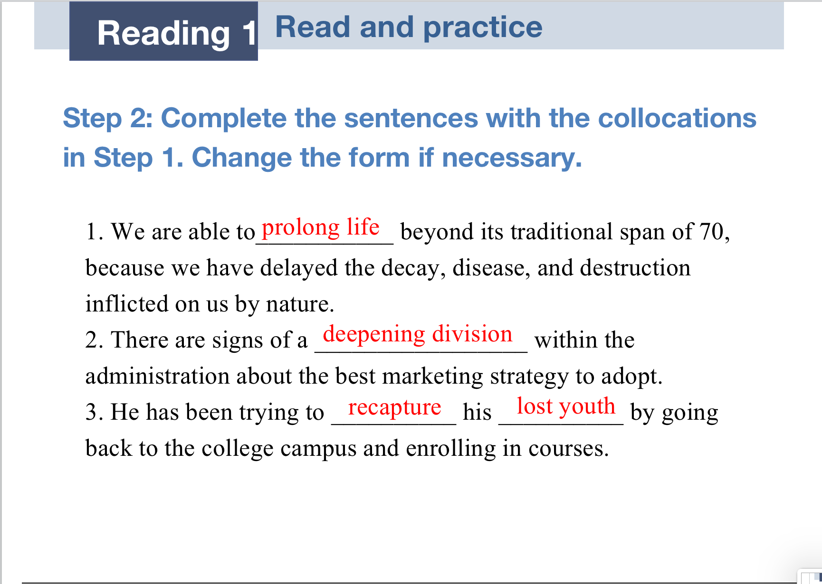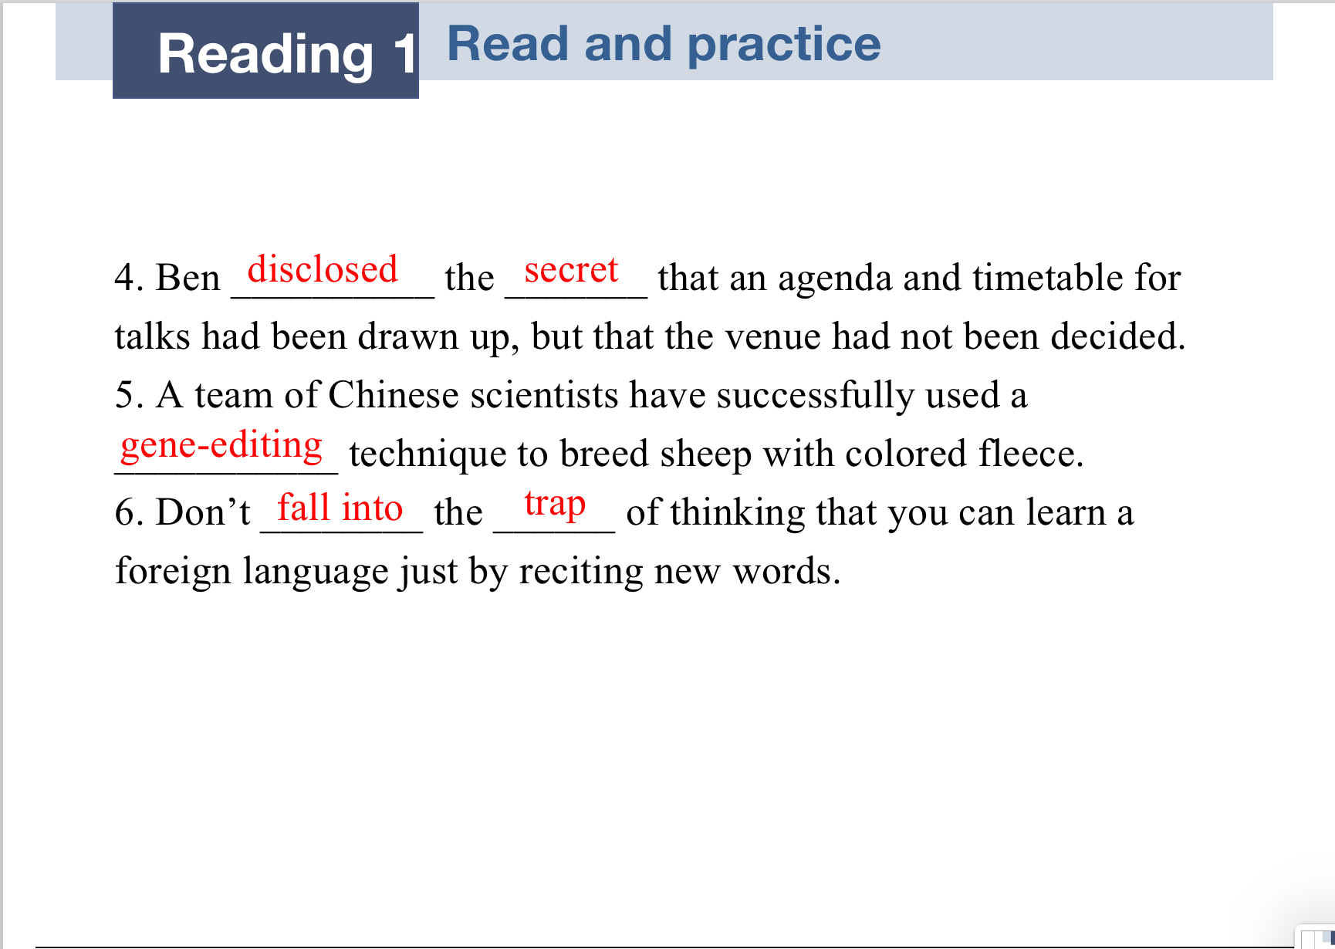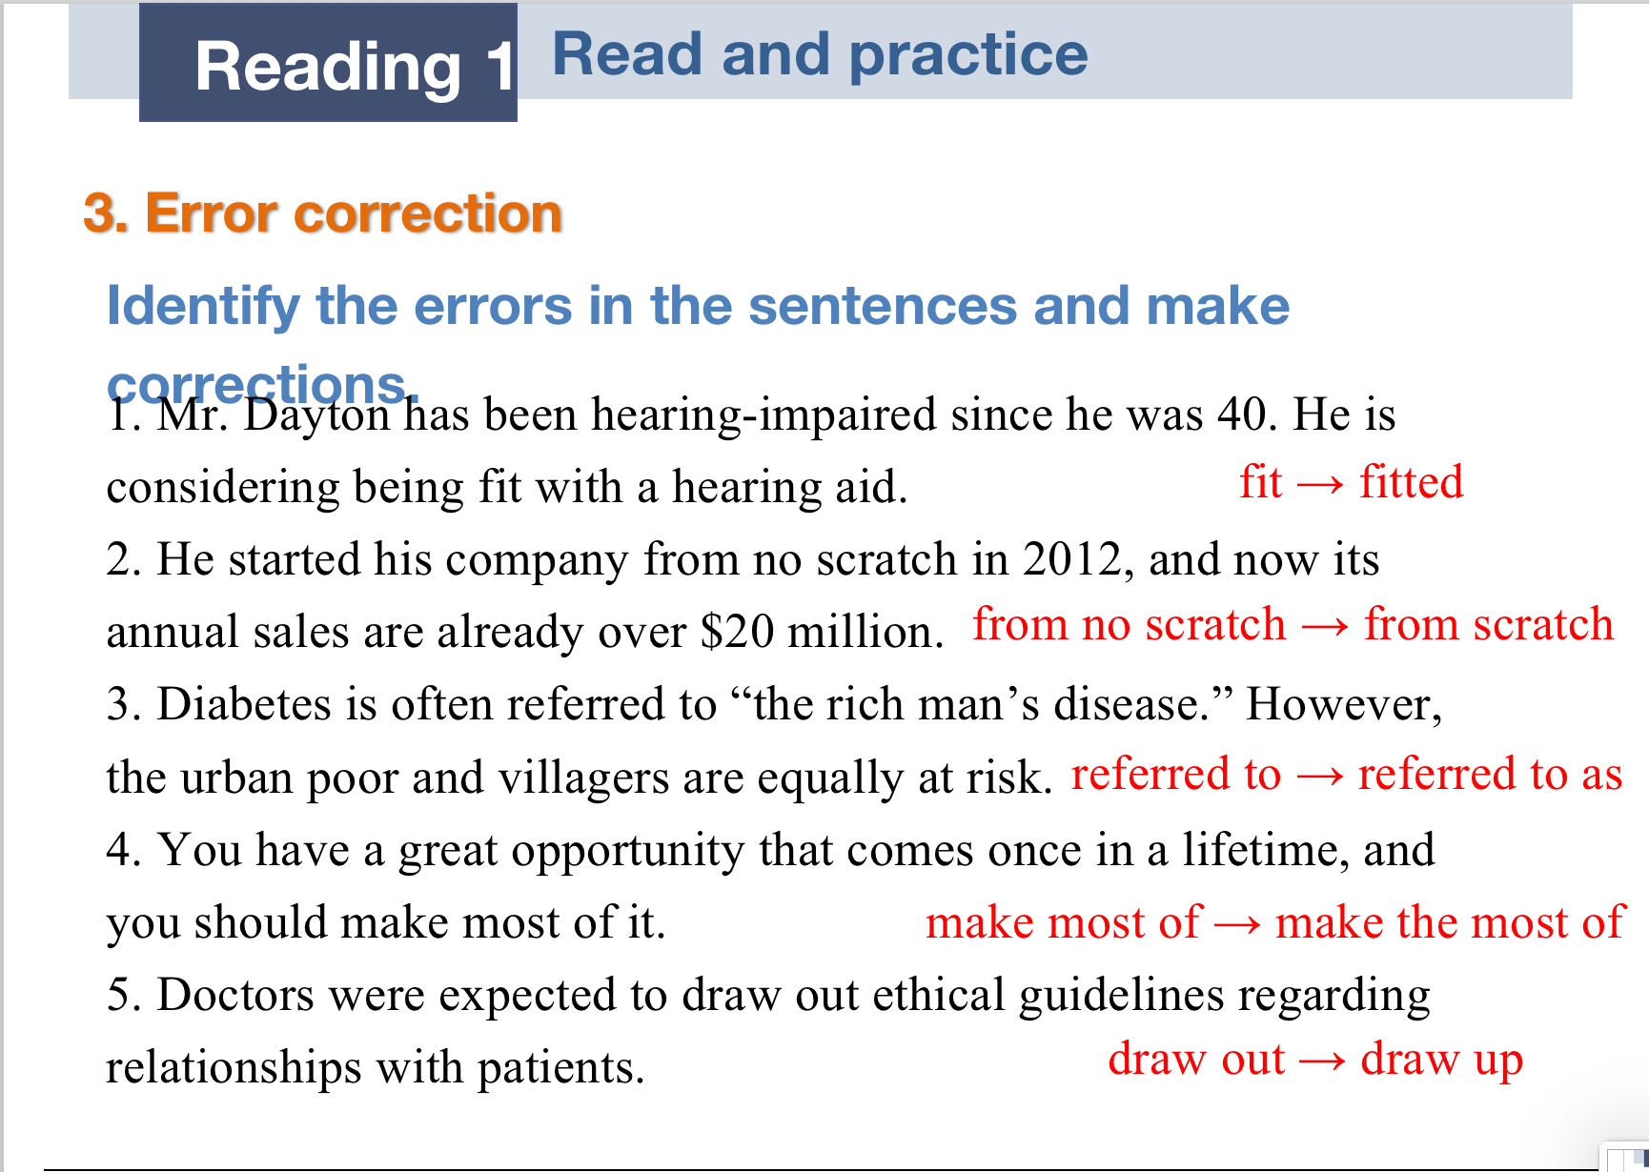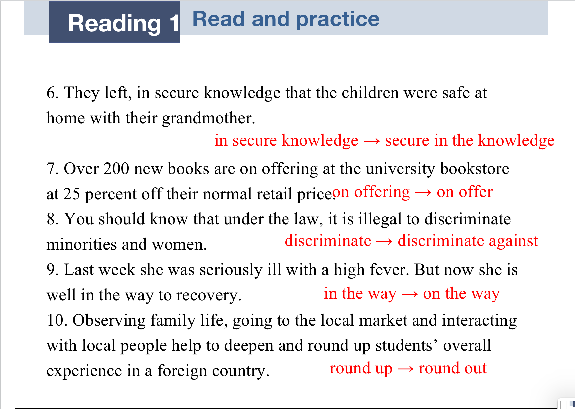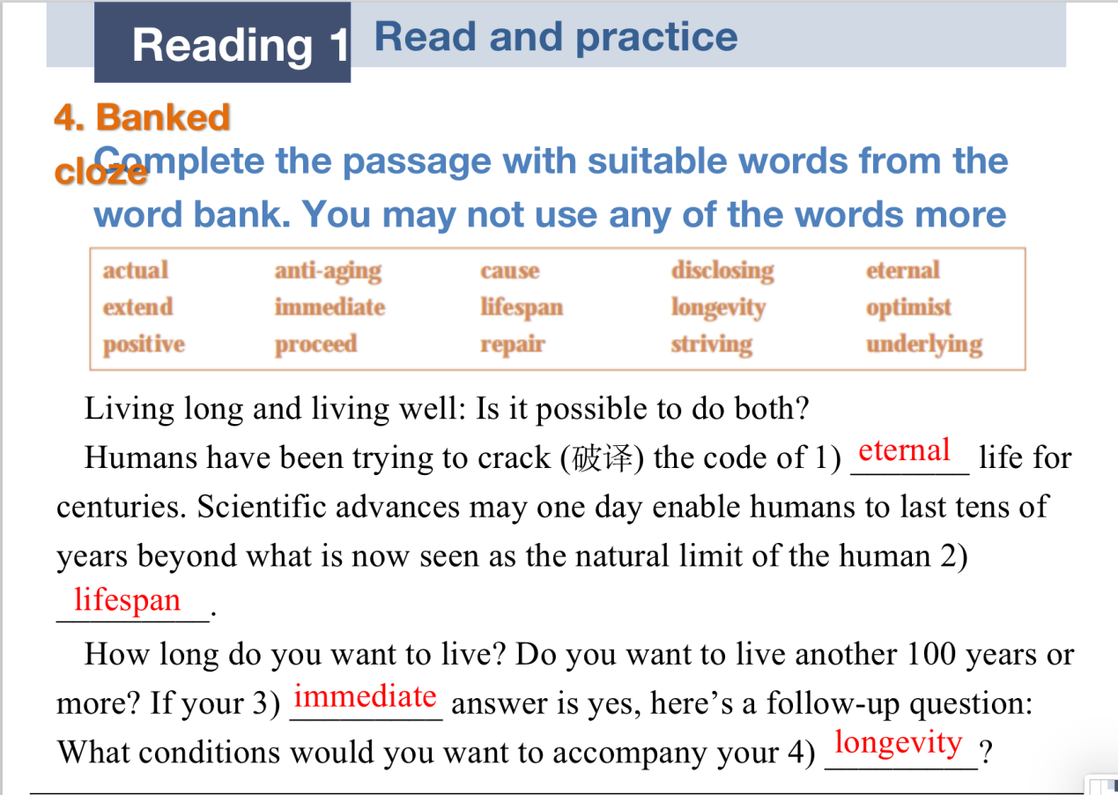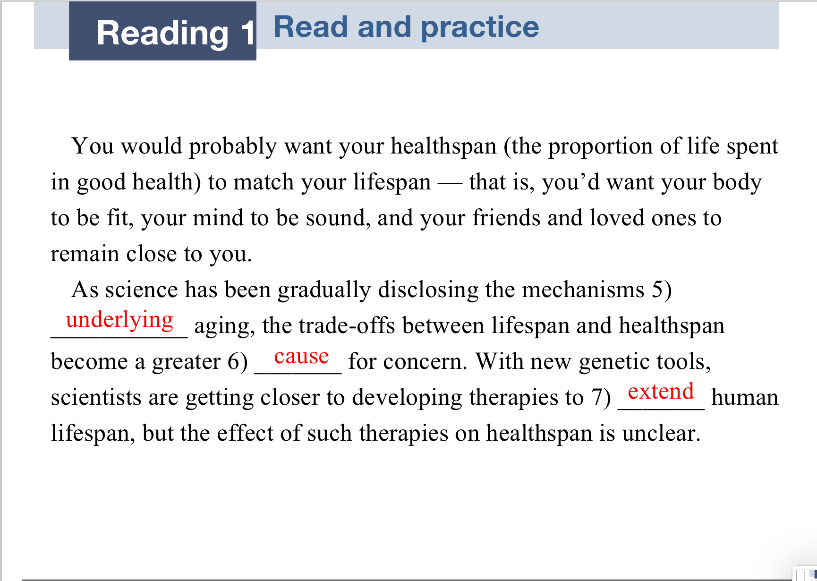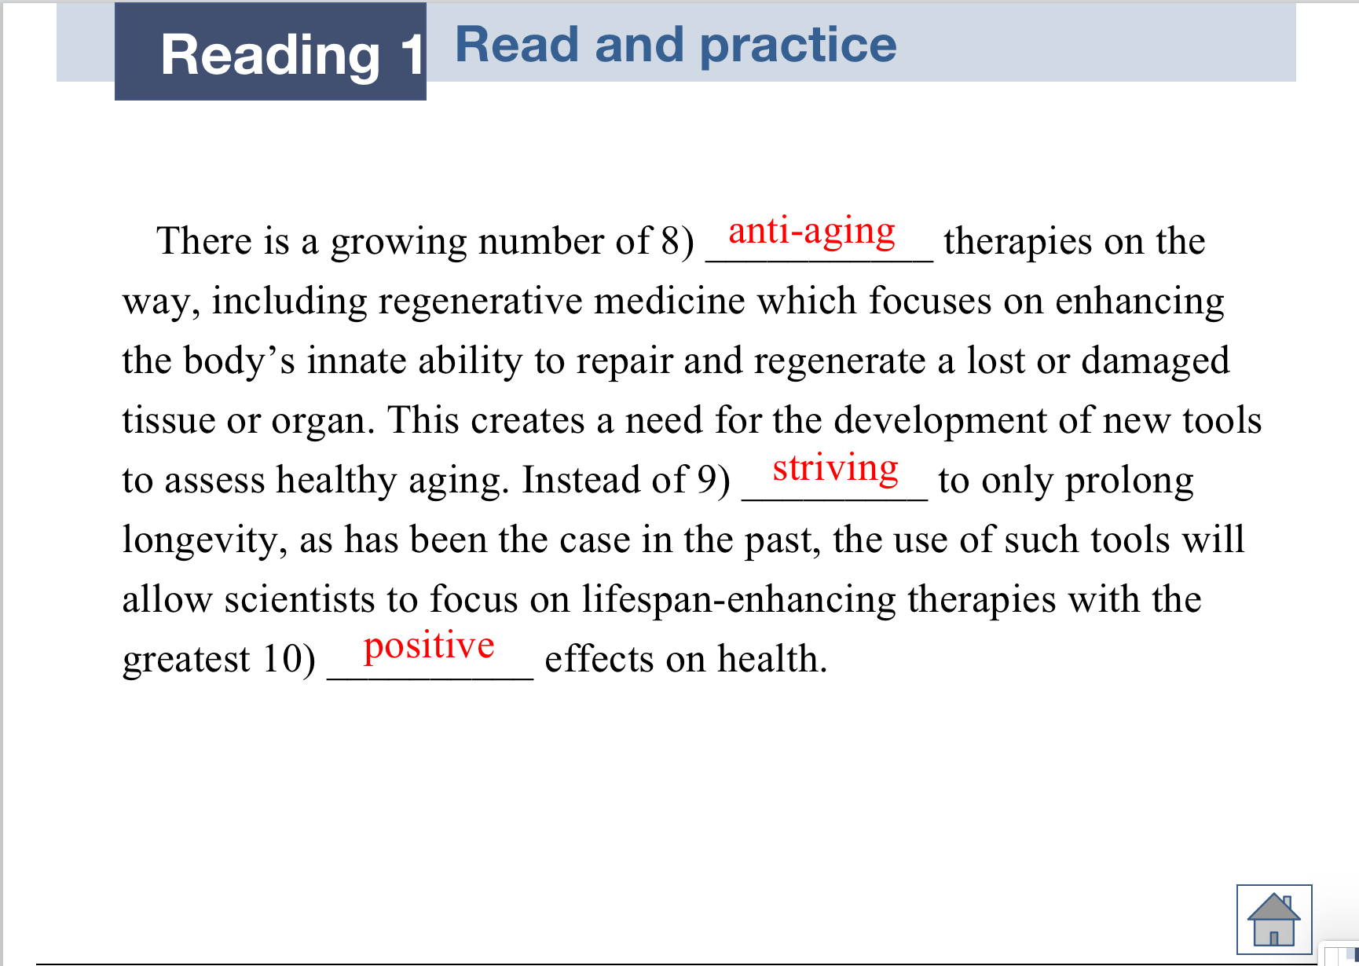

# Reading 1: Read and translate P150

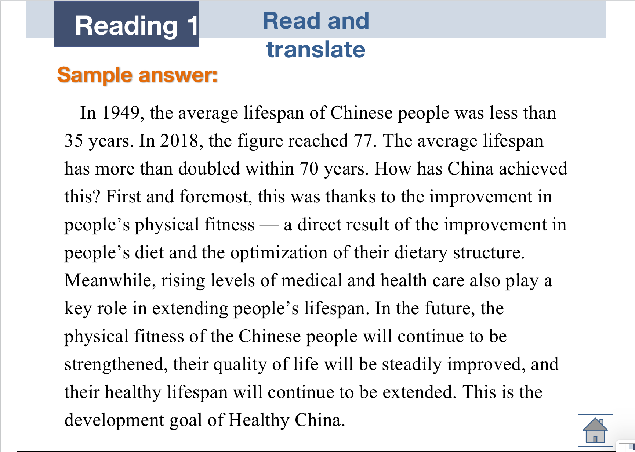

# Reading 2: Get ready to read P151

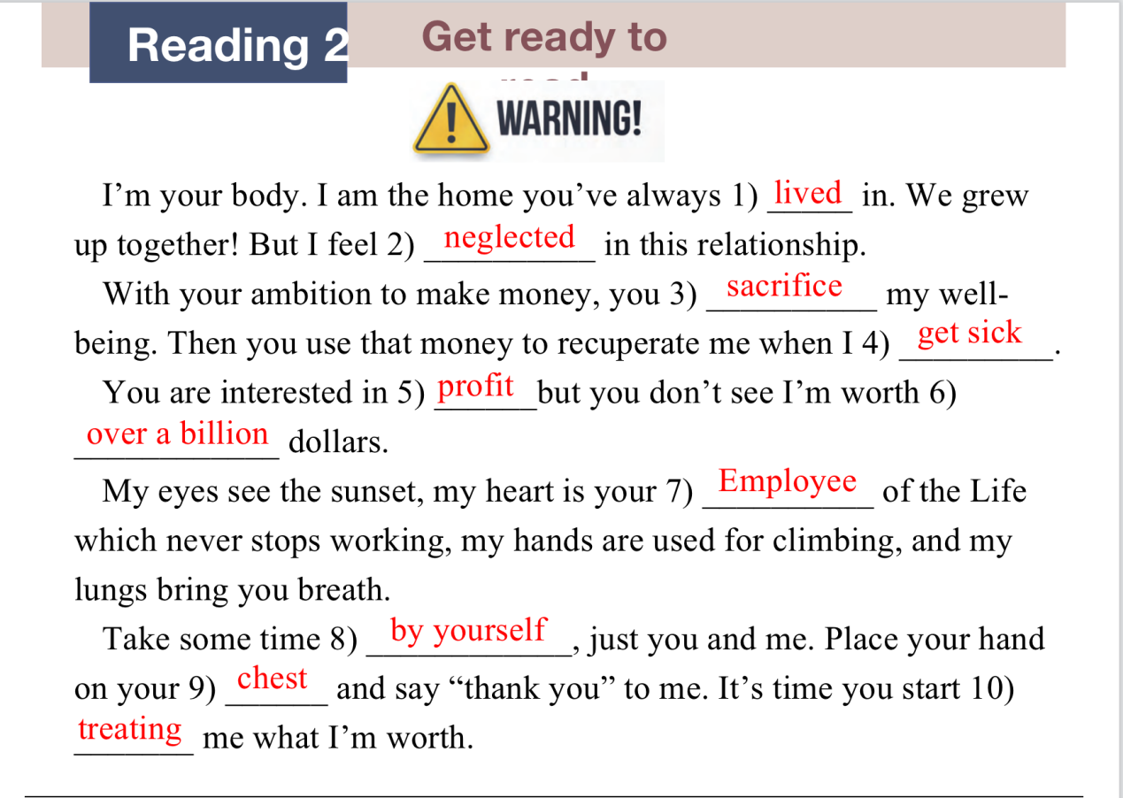

# Reading 2: Read and understand P155

Global understanding:

1) action 2) recipient 3) prompts 4) act on 5) silently 6) receptors 7) matches 8) available 9) functional 10) suggests and completes 11) Disorders 12) sensitive

Detailed understanding: FTFTT

# Reading 2: Read and practice P157

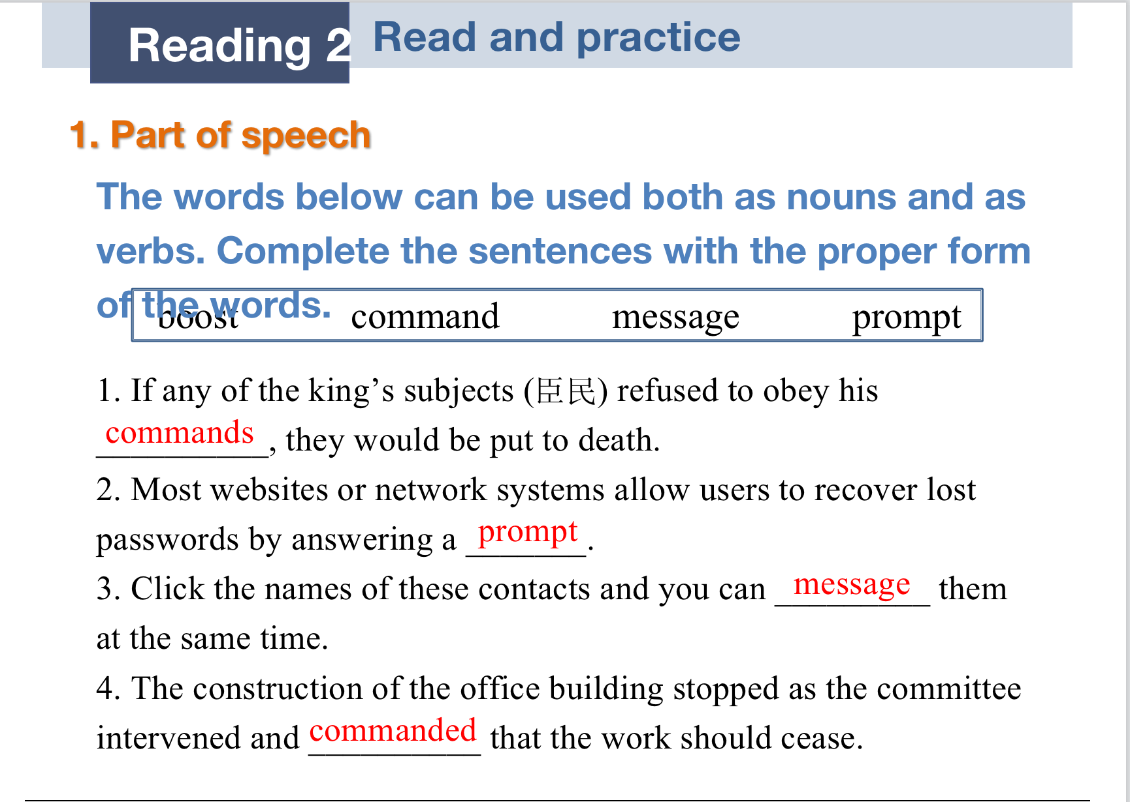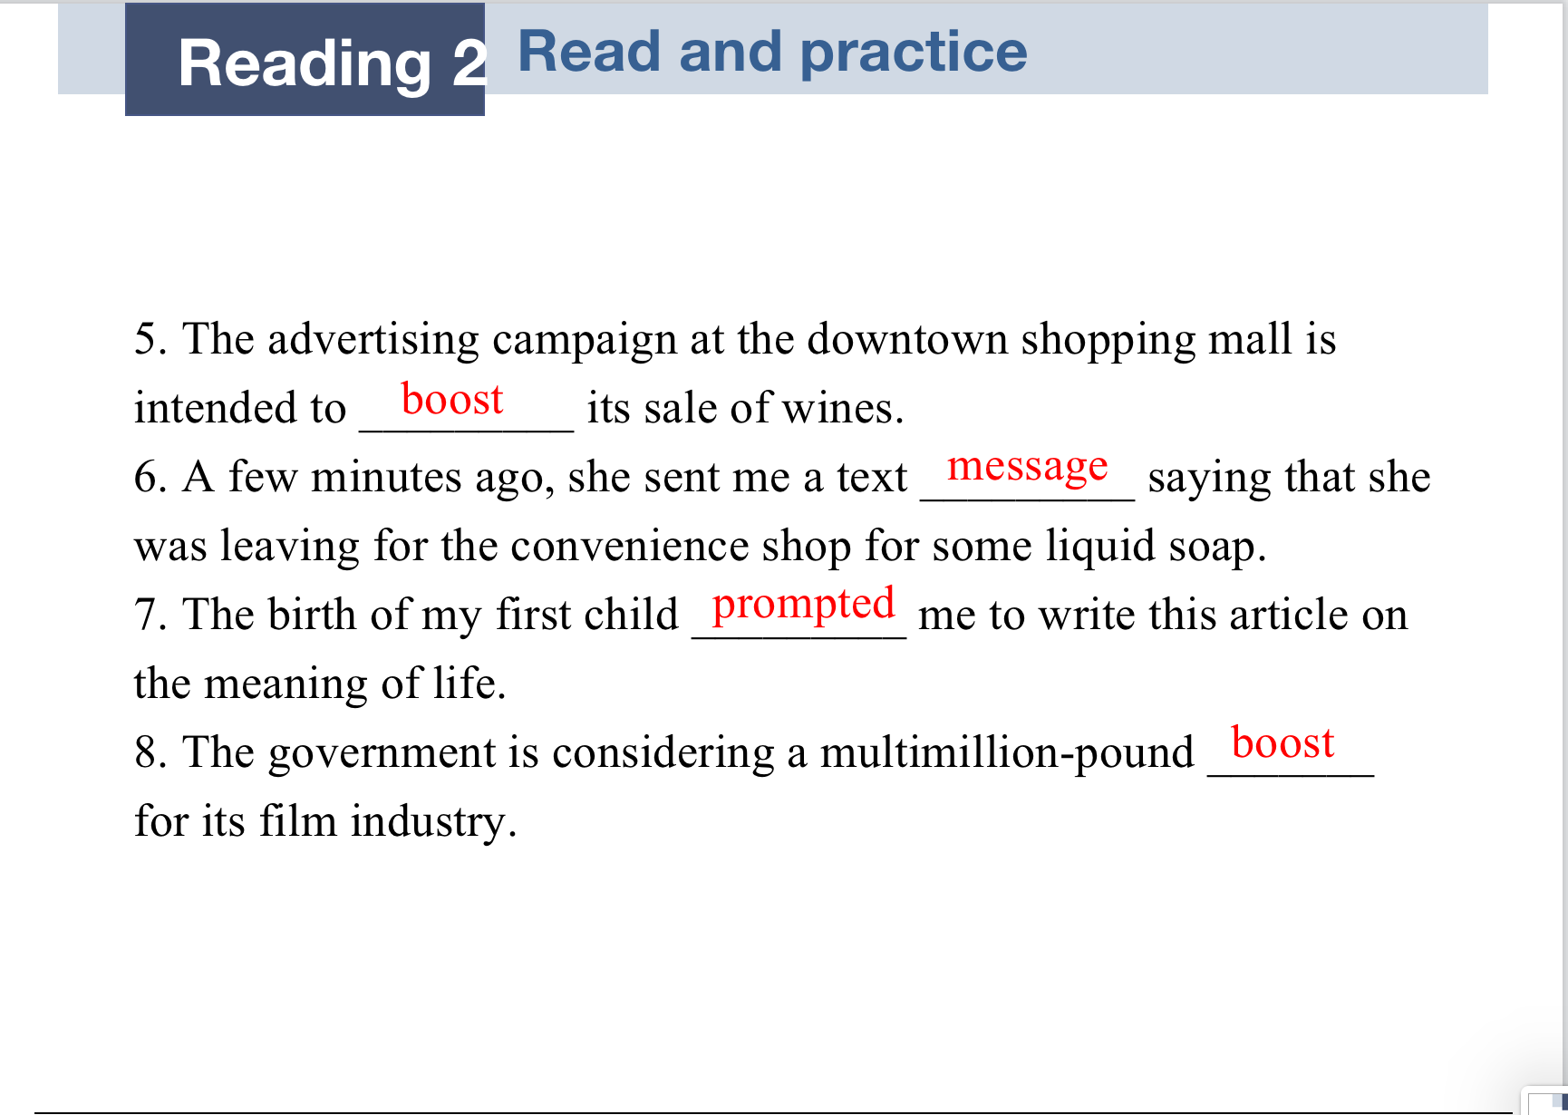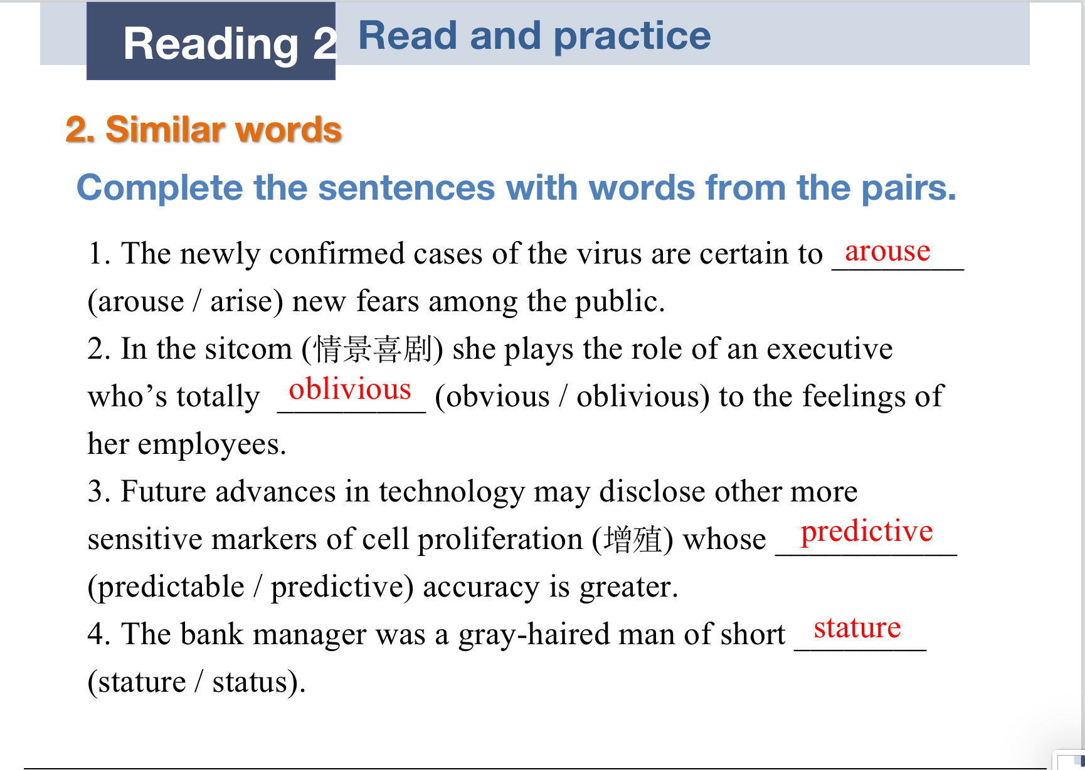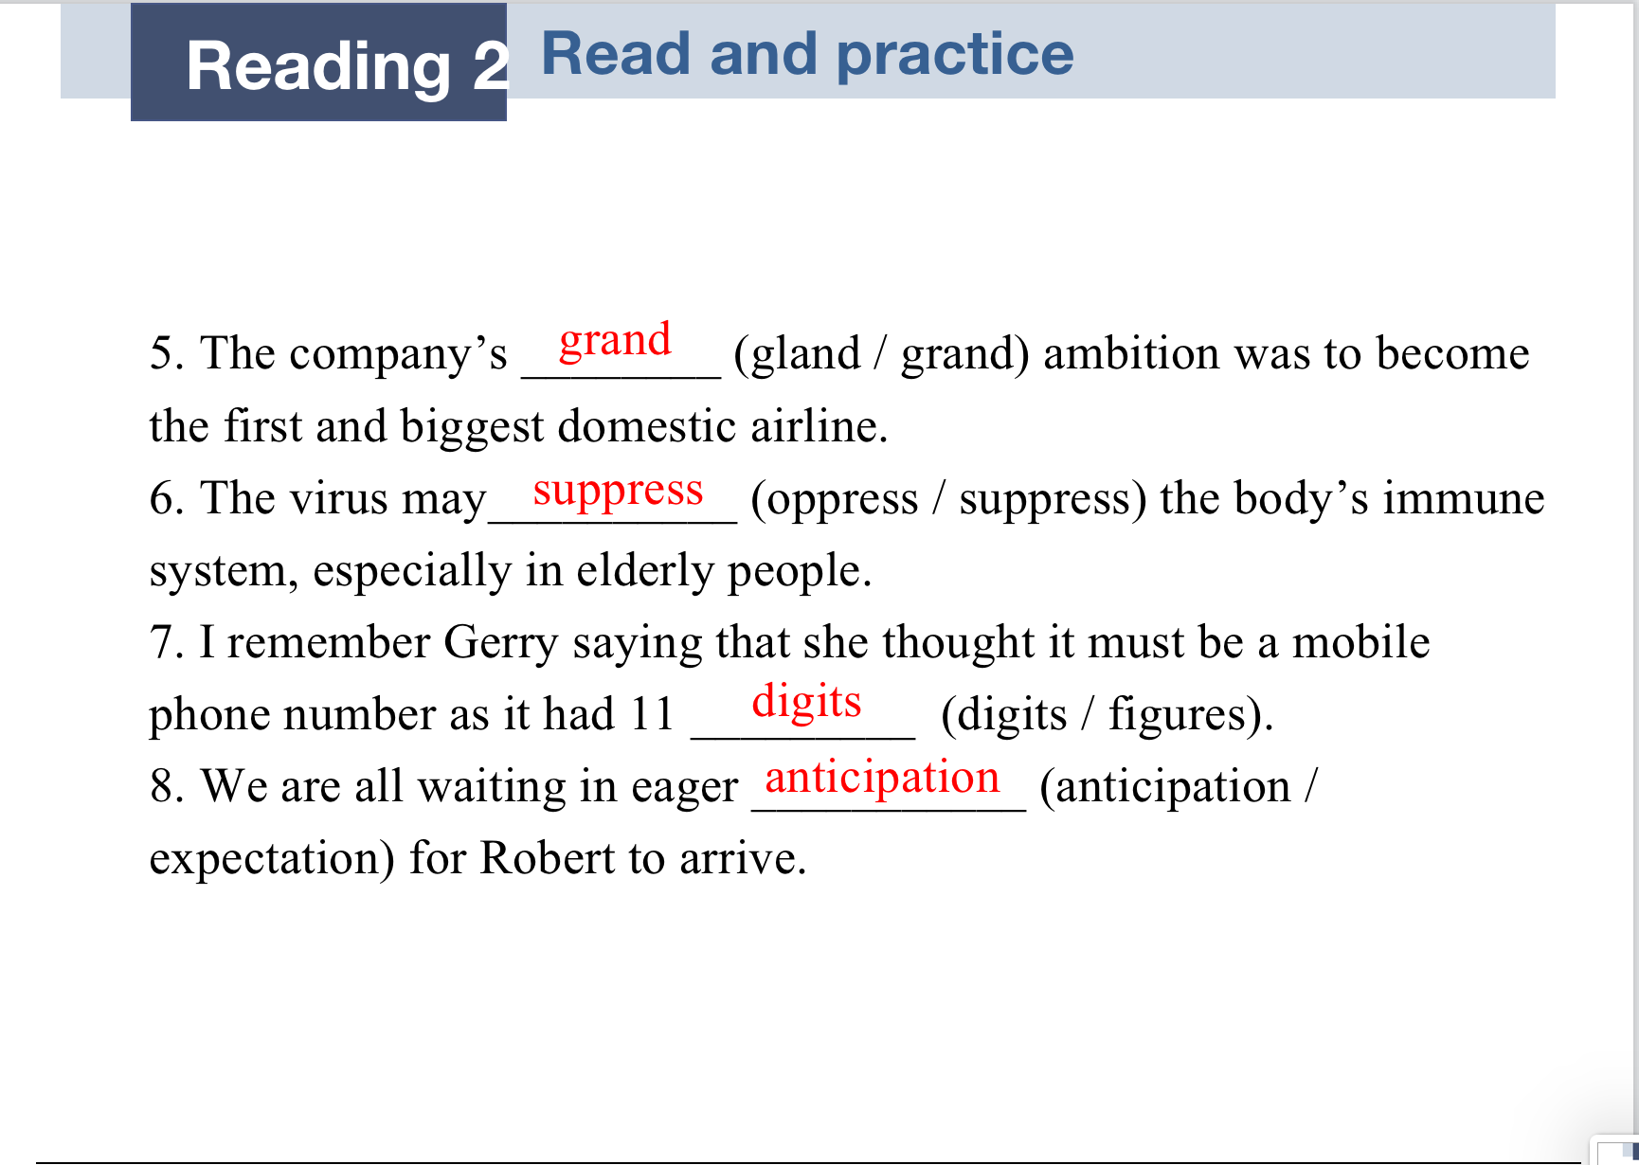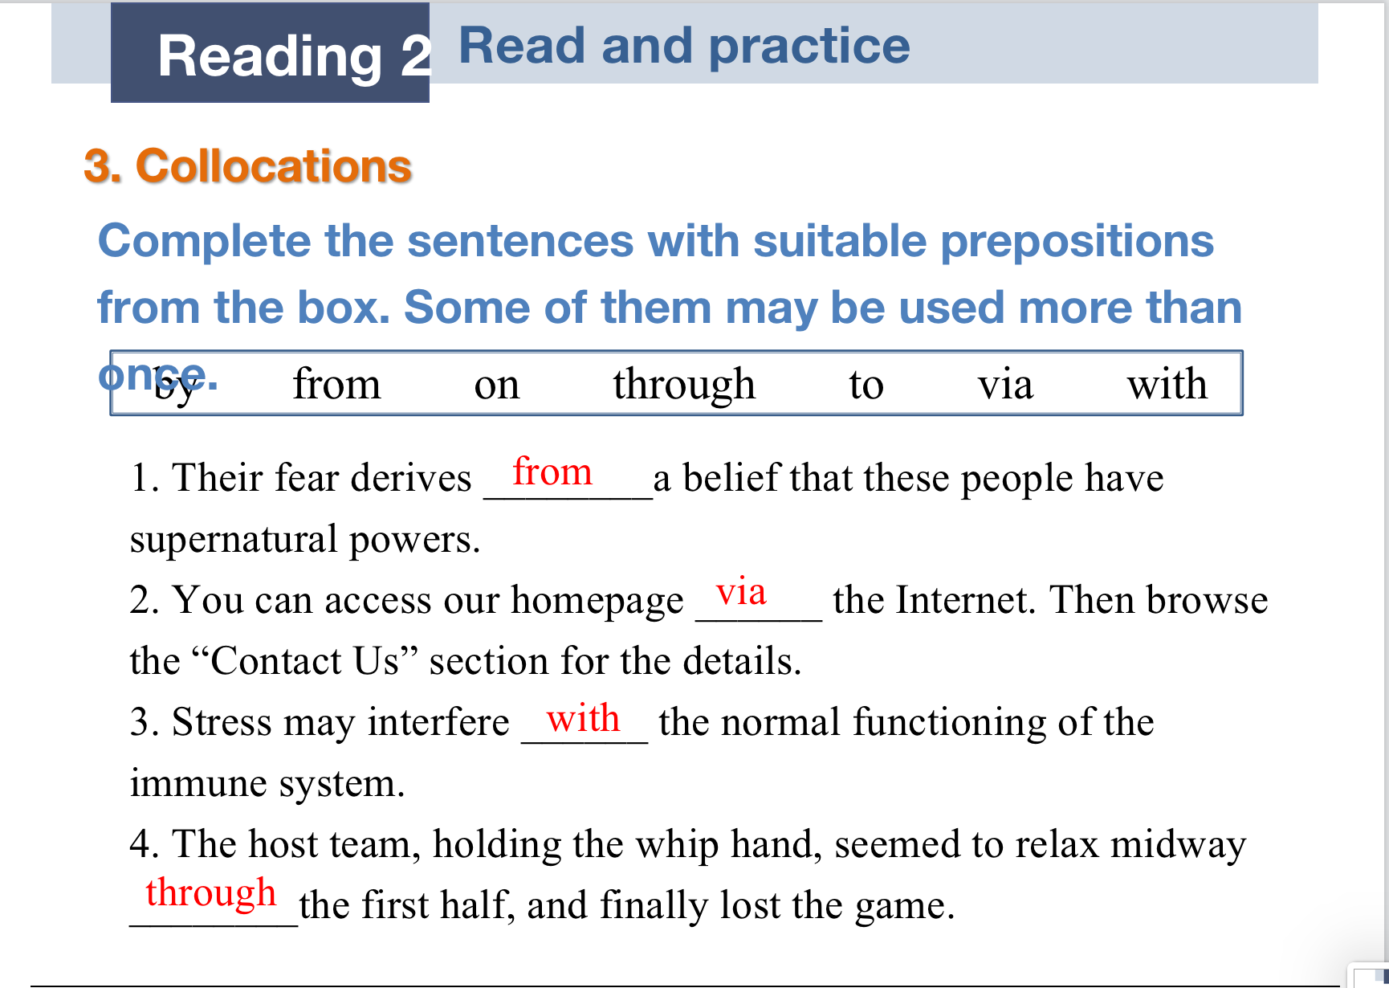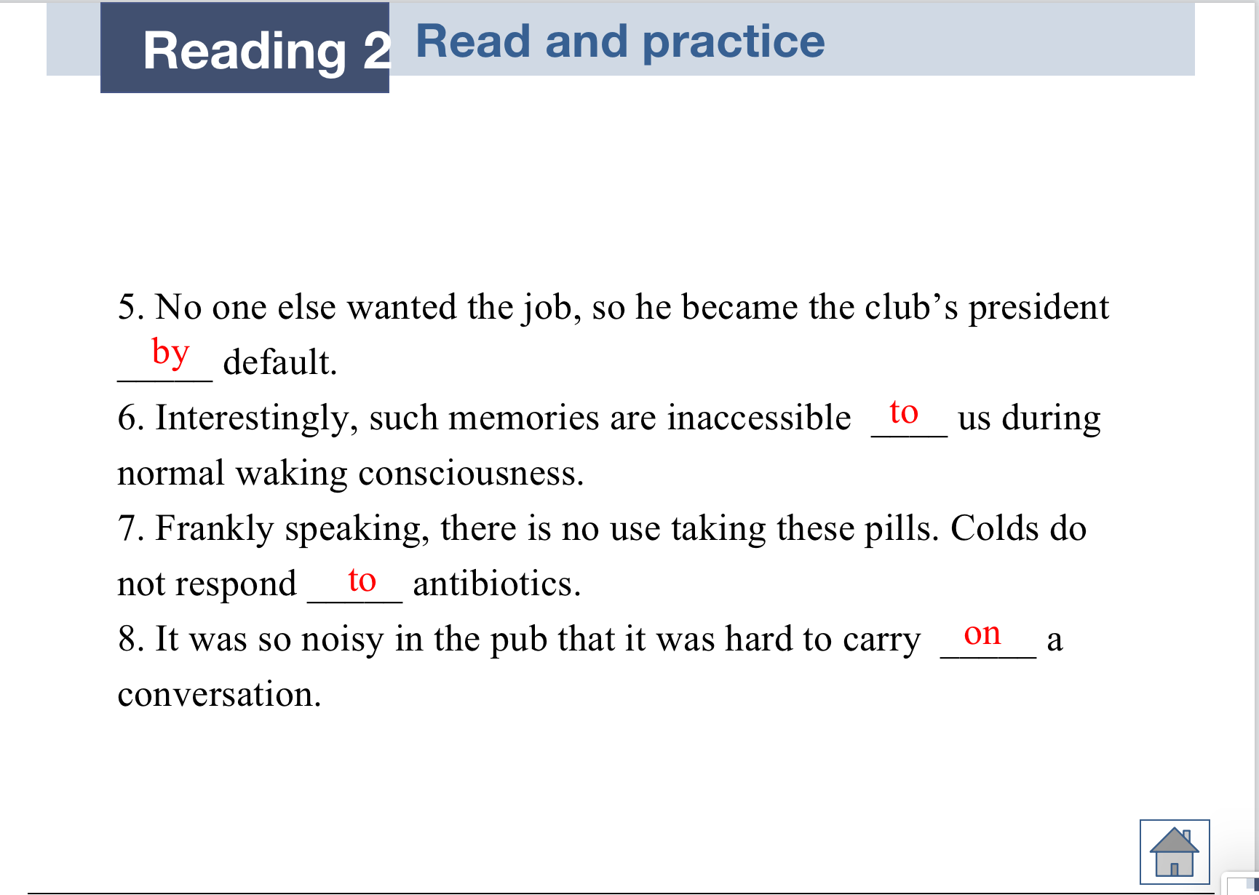

# Reading 2: Read and translate

